SCOPE AND LIMITATION OF THE STUDY

The primary objective of this study is to develop a Blockchain-Based Donation and Relief Transparency System that addresses the issues of mistrust and lack of accountability in traditional donation processes. By utilizing a decentralized ledger, the system aims to provide a tamper-proof and verifiable record of all transactions, ensuring that every monetary contribution reaches its intended recipient without unauthorized intervention. The target users and beneficiaries of this system include donors seeking a transparent way to track their contributions, non-governmental organizations (NGOs) needing an efficient and credible platform to manage relief operations, and student groups facilitating small-scale donation drives for community service or emergency response.

The study and development of the software will be conducted over a period of two (2) months, specifically from May 2026 to June 2026. This timeframe includes the system design, smart contract coding, testing, and final evaluation of the software’s performance. To achieve this, the proposed software features an immutable transaction ledger to ensure data cannot be deleted or altered once stored, and smart contract automation that automatically executes and validates the release of funds once predefined conditions are met. It also provides a real-time tracking dashboard for donors, a secure portal for registered organizations to create relief campaigns, and a digital receipting system that generates unique transaction hashes to serve as digital proof of donation for all parties involved.

However, the study is delimited to the following parameters: the system is strictly limited only to monetary donations and does not cover the tracking or management of in-kind donations. Transactions are restricted exclusively to blockchain-based transfers using Web3-enabled wallets to maintain full transparency and prevent the oracle problem. Operational processes, such as physical beneficiary registration or manual goods distribution, are not handled by the system and remain the sole responsibility of the partner relief organizations.

LIMITATION OF THE STUDY
Internet Dependency
The system requires a stable internet connection because all blockchain transactions are processed online. Poor or unstable connectivity may delay transaction submission and confirmation since the blockchain network needs continuous communication between nodes.

Use of Sepolia Testnet
The system uses the Sepolia Testnet instead of a live blockchain mainnet. Since testnets are intended only for development and testing purposes, the system does not process transactions with actual financial value. Additionally, network performance, transaction speed, and gas fee behavior in real-world production environments may differ from the conditions experienced within the testnet environment.

Network Congestion and Scalability
Blockchain networks may become slow when many users are processing transactions at the same time. Because transactions are validated in blocks, heavy network traffic can cause delays in transaction confirmation.

Gas Fee Fluctuation
Although the system reduces third-party payment fees, blockchain transactions still require gas fees for processing. These fees depend on network demand and may increase or decrease unexpectedly.

Dependence on Third-Party Blockchain Services
The system relies on external blockchain services such as the Ethereum network and wallet providers like MetaMask. Any downtime, maintenance, or technical issues from these services may affect the system’s performance and availability.

Irreversible Transactions
Blockchain transactions cannot be changed or canceled once confirmed. This is a built-in security feature of blockchain technology, but incorrect transactions cannot be automatically reversed by the system.
THEORETICAL FRAMEWORK

The framework of this study is anchored on three established theories and models that support the implementation of a decentralized and transparent system for relief operations.

First, Transparency Theory states that organizations gain trust and credibility when their operations and financial activities are openly accessible and verifiable by stakeholders. In the context of the Blockchain-Based Donation and Relief Transparency System (BBDRTS), this theory is directly relevant because the platform utilizes blockchain technology to provide transparent and immutable donation records. By allowing donors and organizations to track transactions in real time, the system effectively promotes accountability, minimizes the risk of fund mismanagement, and restores donor trust through verifiable data presentation.

Second, the Distributed Trust Model shifts the concept of trust from traditional, centralized institutions to a decentralized network of peers, where transparency and security are maintained through collective verification rather than a single authority. This model is highly relevant to the BBDRTS as it eliminates the reliance on a traditional middleman or third-party payment gateway to validate operations. Instead of trusting a single central entity, the platform leverages peer-to-peer validation and automated smart contracts, ensuring that all donation data and fund routing are verified and permanently recorded by the network consensus.

Lastly, the Technology Acceptance Model (TAM) posits that a user's intention to adopt and utilize a new technology is primarily determined by its perceived usefulness and perceived ease of use. Within the scope of this project, TAM provides a foundational understanding of how independent NGOs, student organizations, and individual donors will adapt to a decentralized web application. The system's capacity to deliver tamper-proof records directly addresses its perceived usefulness by ensuring absolute data integrity, while the front-end web interface is specifically designed to optimize ease of use for stakeholders who are otherwise unfamiliar with handling Web3 wallets.

CONCEPTUAL FRAMEWORK AND DESIGN

IPO Model and Process Diagrams
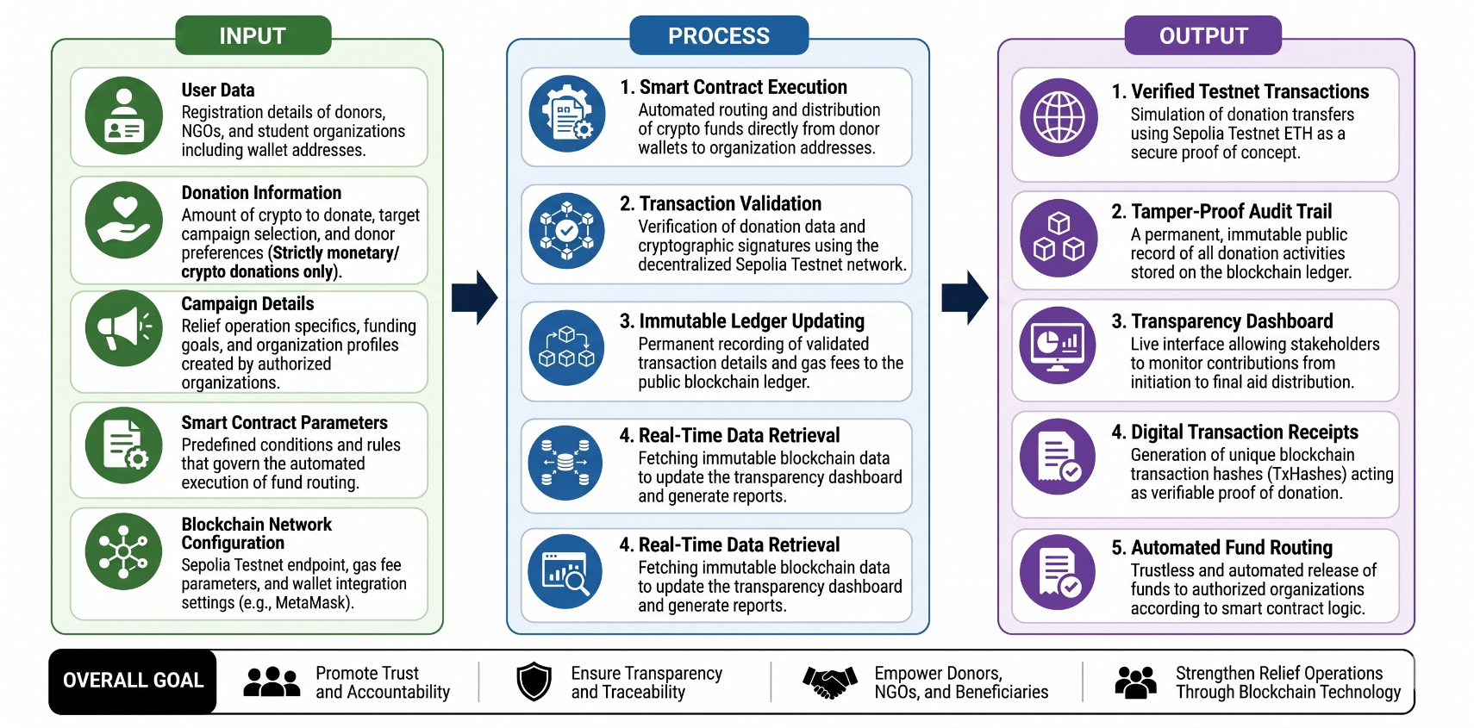
The conceptual framework of the Blockchain-Based Donation and Relief Transparency System (BBDRTS) is structured using the Input-Process-Output (IPO) Model to illustrate the logical flow of the system's core operational functionality. This framework provides a systematic mapping of how user requirements and cryptographic configurations are processed by the decentralized architecture to produce a transparent and tamper-proof auditing environment for relief operations.

The Input phase encompasses the essential data and cryptographic configurations required to initialize the system's ecosystem. This includes donor, NGO, and student organization user data, which links their system profiles directly to their unique Web3 wallet addresses. It also captures cryptocurrency donation information—specifically restricted to monetary digital assets to prevent the oracle problem—alongside authorized campaign details created by verified organizations. Finally, this phase integrates smart contract parameters and blockchain network configurations, such as the Sepolia Testnet endpoints and MetaMask wallet integration settings.

The Process phase represents the automated, real-time backend and blockchain-level operations that transform the initialized inputs into functional, secure data states. This covers automated smart contract fund execution, which programmatically routes crypto assets directly from donors to targeted organization addresses without manual third-party intervention. It also includes cryptocurrency transaction validation and cryptographic signature verification executed via the decentralized Sepolia Testnet network nodes. Once validated, the system performs permanent, immutable updating of the public blockchain ledger and handles real-time data retrieval to dynamically update the web application's user interface.

The Output phase details the tangible, verifiable deliverables generated by the platform as a result of these automated network functions. The primary output is verified testnet transactions that simulate secure, zero-cost asset transfers, establishing a permanent and tamper-proof audit trail on the public blockchain ledger. This data populates the live transparency dashboard interface, allowing donors and administrators to monitor contributions from the exact second of initiation down to the final distribution. Lastly, the system outputs digital transaction receipts containing unique transaction hashes (TxHashes) and triggers trustless automated fund routing directly to the partner organization's Web3 wallet. Together, these interconnected phases demonstrate how decentralized ledger technology is applied to enforce financial accountability and eliminate the vulnerabilities of fraud and mistrust that historically compromise traditional relief operations.

Design of Software, Systems, Product and/or Process

To further elaborate on the actual behavioral flows, structural boundaries, and data management mechanisms of the BBDRTS, the architectural design is modeled using Data Flow Diagrams (DFDs) and an Entity-Relationship Diagram (ERD). These structural models visually depict the interfaces, logical sub-processes, and strict relational constraints governing the platform.

1. Context Diagram (Level 0 DFD)
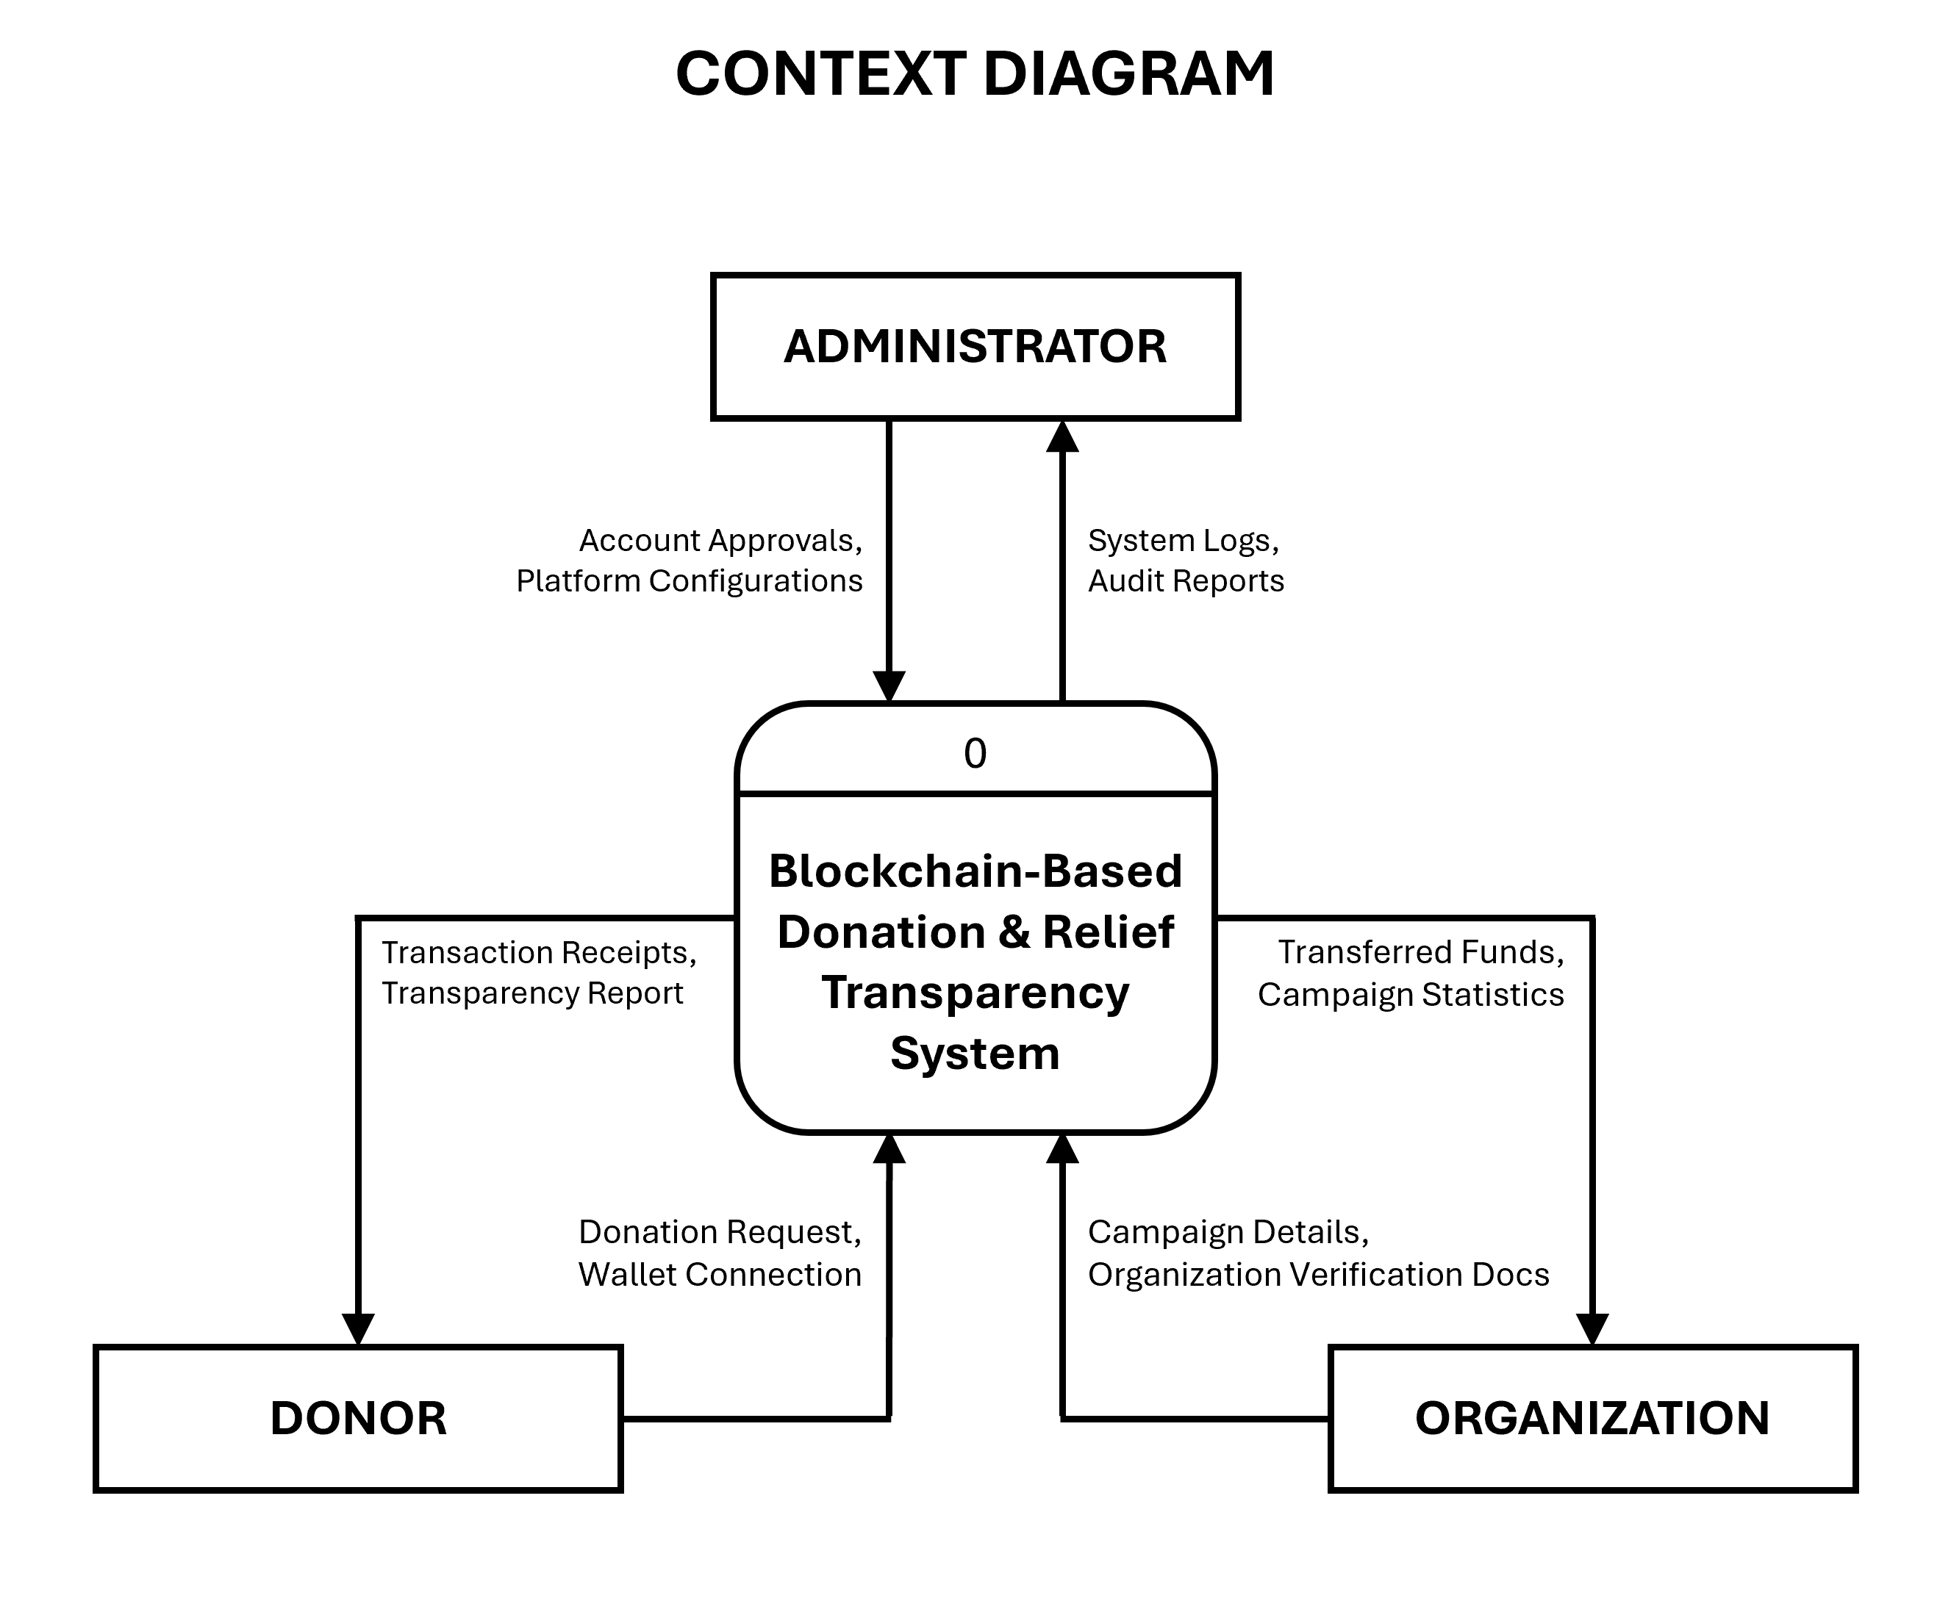
The Context Diagram establishes the baseline boundary of the BBDRTS by representing the entire platform as a single system process interface (Process 0) interacting directly with the external entities: the Administrator, the Donor, and the Recipient Organization. It defines the high-level inputs and outputs without diving into sub-system complexities.

2. Level 0 Data Flow Diagram
The Level 0 Data Flow Diagram expands the central system process into detailed functional sub-processes: Manage Accounts & Platform (1.0), Manage Relief Campaigns (2.0), Process Donations via Smart Contract (3.0), and Generate Transparency Reports (4.0). It illustrates how data transitions dynamically through these sub-processes and maps out the distinct boundaries between the off-chain application database and the immutable on-chain ledger.
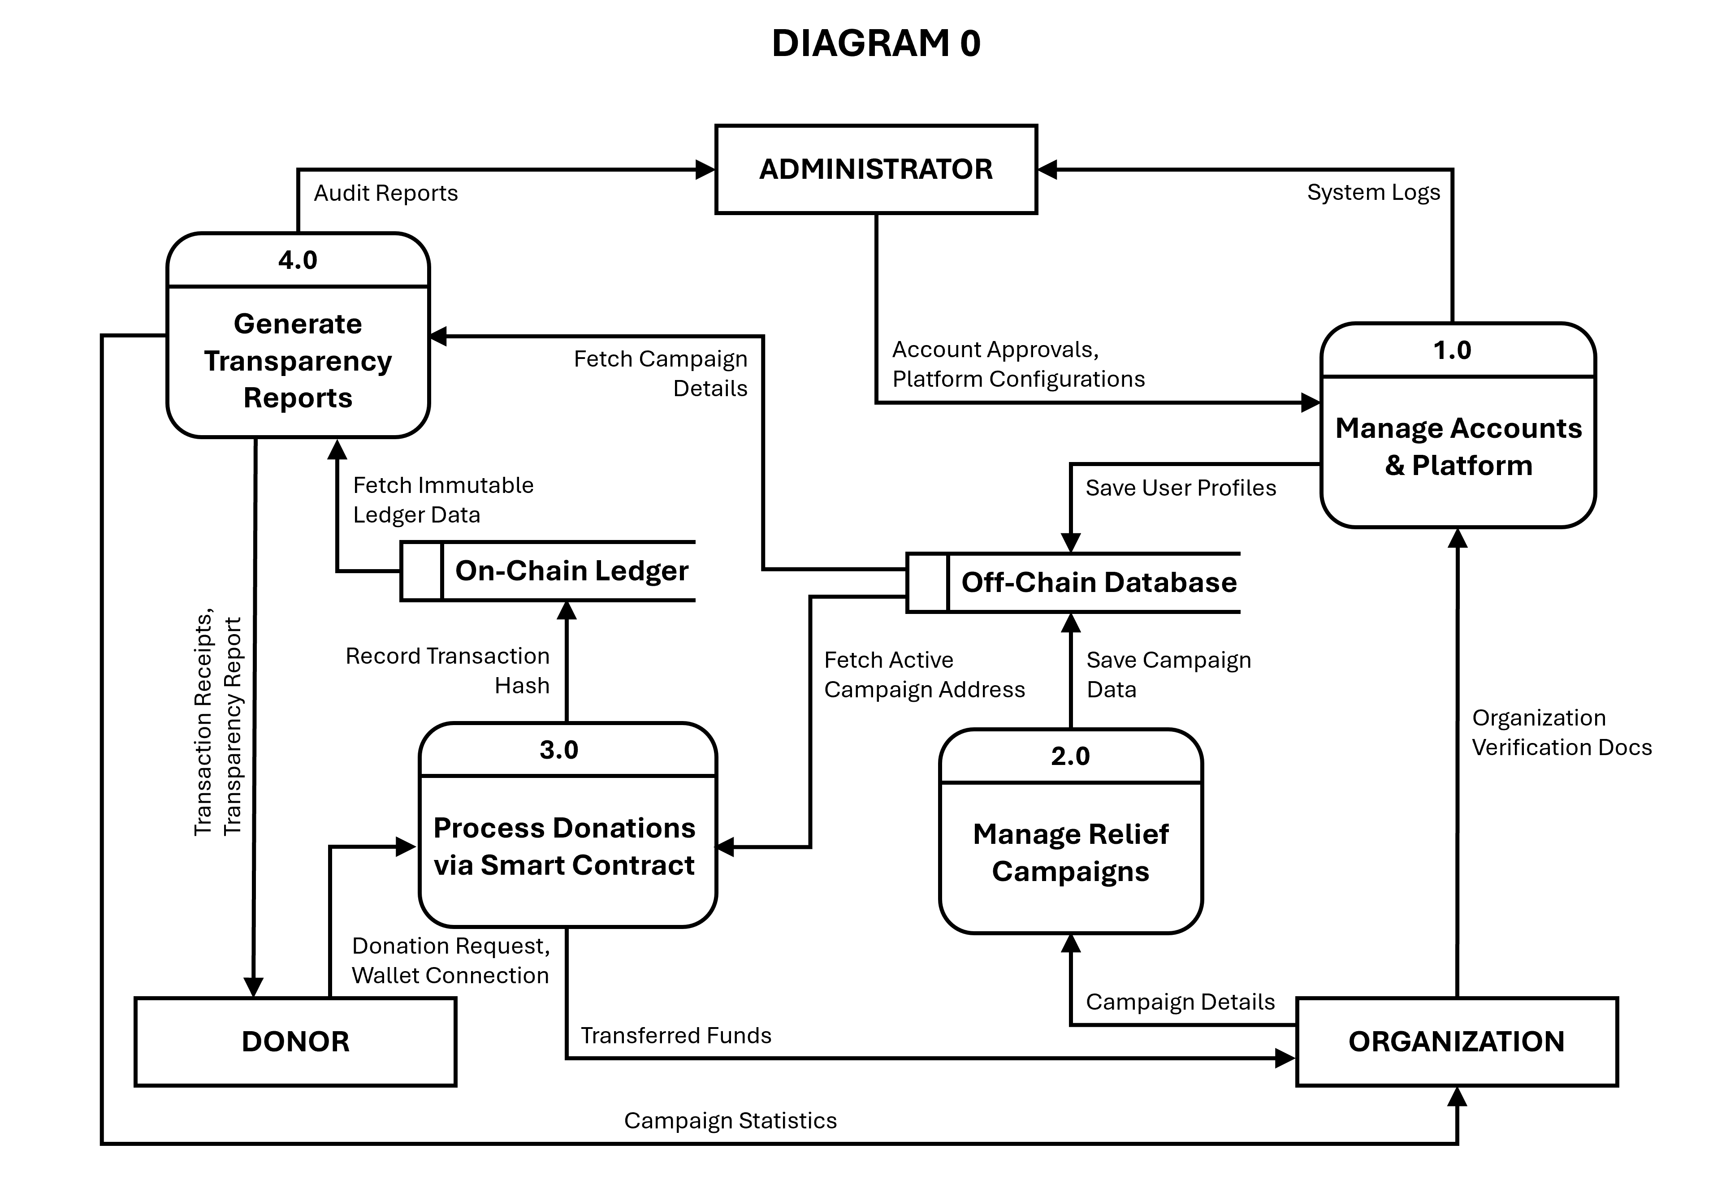

3. Entity-Relationship Diagram (ERD)
The Entity-Relationship Diagram maps the logical and physical layout of the database schema supporting the BBDRTS. To maintain absolute operational normalization and strictly adhere to relational integrity, all many-to-many relationships are resolved using the Donation Transaction entity as a junction table. The schema ensures structured entity mappings across the Administrator, Organization, Campaign, Donor, and Transaction tables using explicit Primary Key (PK) and Foreign Key (FK) relational paths.
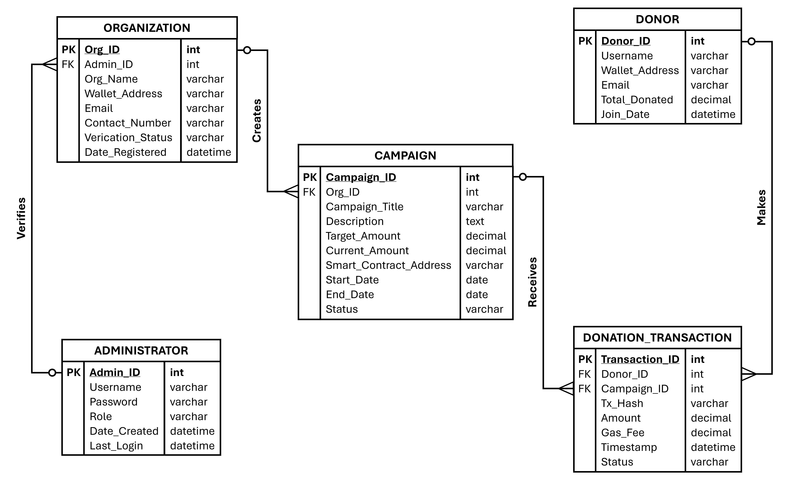

METHODOLOGY AND SOFTWARE EVALUATION

Design and Methodology
This study will utilize the Agile Software Development Methodology in developing the Blockchain-Based Donation and Relief Transparency System (BBDRTS). Agile methodology is highly suitable for this study because it allows for an iterative approach where the system is developed step by step through continuous cycles of planning, designing, coding, testing, and structural improvement. Since the platform involves distinctly different users—specifically donors, non-governmental organizations (NGOs), and administrators—the Agile framework helps the development team make swift operational adjustments based on user requirements and collaborative feedback gathered during the development lifecycle. The systematic development of the BBDRTS follows six core operational phases.

During the Requirement Analysis phase, the core needs and structural requirements of the platform are comprehensively identified . The primary user pathways are established: donors must be able to securely connect Web3 wallets, execute monetary donations, and view historical transaction receipts; partner organizations require interfaces to deploy relief campaigns, monitor incoming ledger transfers, and post operational updates; and administrators must access dashboards to manage platform users, verify NGO registration documents, monitor network activities, and audit system performance logs . This phase also analyzes the persistent vulnerabilities within traditional donation management environments, such as a severe lack of real-time transparency, the high potential for database tampering, and heavy reliance on centralized third-party payment gateways. These identified criteria serve as the explicit foundation for the system design and coding iterations.

In the System Design phase, the blueprint of the software architecture is formulated through Context Diagrams and Data Flow Diagrams (DFDs) . These behavioral models visually map out how sensitive information flows securely between the system and its external entities . Structurally, this phase establishes a clear architectural division: an off-chain application database is utilized to securely manage standard user credentials, relief campaign descriptions, and administrative verification documentation, while decentralized blockchain ledger infrastructure is reserved strictly to record active smart contracts, automated cryptocurrency transactions, and permanent transaction hashes. This multi-tier architecture optimizes data security while enforcing absolute system transparency.

During the System Development phase, the actual web-based prototype is programmatically constructed based on the approved specifications. Development activities are focused on frontend user interfaces, secure registration frameworks, campaign creation blocks, and interactive transparency dashboards. Crucially, Web3 technology modules are integrated to bridge the user interface with the blockchain network, deploying specialized smart contracts written in Solidity to fully automate and cryptographic validation of donation handshakes directly between peers without human or institutional intermediaries.

In the Testing and Debugging phase, the software undergoes exhaustive testing iterations to confirm that all technical elements execute without failure . The test scripts focus heavily on MetaMask wallet configurations, successful smart contract deployment, cryptographic transaction validation, accurate TxHash retrieval, and automated dashboard updating. To protect developer resources and prevent real financial loss during structural iterations, testing is executed entirely within the isolated environment of the Ethereum Sepolia Testnet. Any runtime errors, logic flaws within the smart contracts, or front-end integration bugs caught during this period are systematically debugged and corrected before advancing to stakeholder verification.

During the System Evaluation phase, the finalized prototype is rigorously evaluated using standardized software quality instruments, specifically tracking criteria like functionality, reliability, usability, efficiency, maintainability, and portability. This formal process provides quantifiable metric verification regarding whether the decentralized platform functions as a secure, efficient, and user-friendly alternative to legacy systems. Evaluator insights, feedback data, and user surveys are analyzed to fine-tune system latency and ensure the application perfectly fits the core objectives of the study.

Finally, in the Implementation and Documentation phase, the final production build of the software is secured alongside its extensive project documentation. This encompasses the compilation of verified DFD models, database schema configurations, smart contract transaction receipts, user evaluation spreadsheets, and system operator instructions. This phase guarantees that the completed BBDRTS framework is soundly documented, reproducible, and ready for public demonstration and final thesis defense.

